**Objective**: In this lab you will learn how to use MySQL on RPi to collect data.

**Required Setup**: The installation steps of MySQL in lab 1.

**Parts:**

* RPi 3 B
* GrovePi+ board
* Two Grove connection wires
* 1 x Grove Temperature and Humidity Sensor
* 1 x Grove LCD RGB Backlight v2.0

**Part A: Basic SQL command**

You might notice the DBMS’s name is MariaDB. The Raspbian OS we installed on Raspberry Pi is based on Debian v9, which uses MariaDB and it’s MySQL compatible. The previous version of Debian was using MySQL. Because the extra steps of installation of MySQL might cause confusion, we are going to stick with MariaDB for this whole course because we can use exactly same MySQL command in MariaDB as well.

Every SQL statement consists of reserved words and user-defined words. Reserved words are a fixed part of SQL and must be spelled exactly as required and cannot split across lines. User-defined words are created by user and represent names of different database objects like table, columns, etc. SQL uses the general terms **table**, **row**, and **column**. Now, let’s start with 3 basic SQL commands ---- **CREATE**, **INSERT**, **SELECT**.

Open the terminal. Let’s try those commands in the MariaDB.

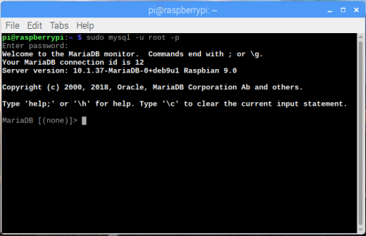

First, we can type “**show databases;**“ to check the current databases in the MariaDB. These are created by default.

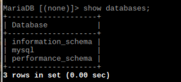

Next, type “**create database test1;**”. Then type “**show databases;**“. You can see test1 is in the list.

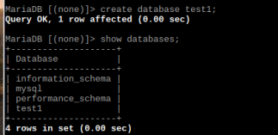

Type “use test1;”. Now we are in the database test1.



Now, we are going to create a table called “student”. Each student has the first and last name, email, birth date, and student id. Let’s create this table in MariaDB. Type following command.

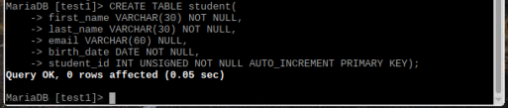

We use CREATE TABLE [table name](variable name variable data type NULL/NOT NULL, …., …. ); to create a table. Each student will have a “**primary key**”, which is a not null value and unique to each student. In our case here, it’s student id and “**AUTO_INCREMENT**” indicates that the value of the primary key will be incremented automatically. The primary key plays a very important role in database setup, but we are not going to dive deep here. There are a lot of database course videos online if you are really interested.

For the data types, VARCHAR is a character string with a length that’s variable. INT is a integer value from -2^31 -1 to 2^31. DATE is specifically used for storing date in YYY-MM-DD format. There are a lot more data types in SQL and you can find them here: <https://www.w3schools.com/sql/sql_datatypes.asp> . Now type “describe student” and you will see all the details and descriptions of the table we just created.

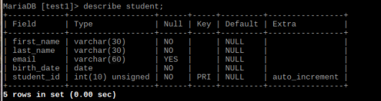

We use INSERT INTO [table name] VALUES (xxx,xxx,xxx); to insert students. Type the following command.



Since we have “**AUTO_INCREMENT**” for our primary key, simply just type NULL for the value.



Go ahead and insert the other two students. The information can be found in the image below.

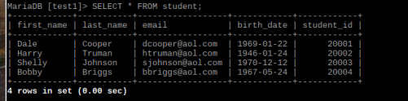

Execute “**SELECT * FROM student;**” to get the exact same table above. “**\***” means I want everything. Now we are done with the student table and you learn some fundamental knowledge of these 3 SQL commands. It’s time to continue our Raspberry Pi project for this week.

**Part B: Data collection and storage with MariaDB**

**Step 1**. Next, we need to set at all privileges for the user “root”. Run the following command to get in MariaDB.



**Step 2.** It’s time for you to create a table to get prepared for collecting data. Use the previous tutorial in part A to generate a table called “Temp_Hum_Sound” exactly like below in ‘test1’ database.

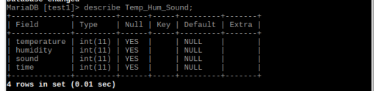

**Step 3.** After creating the table, type following SQL commands to grant privileges. Press ‘enter’ key after each line. **As soon as you execute the first line, your MariaDB root password will be set to ‘test’.** Don’t be panic if your old password does not work.



**Step 4.** Run following commands to restart MariaDB.



**Step 5.** We need to install a mysql package to be able to connect with the MariaDB database because we will be running a python script. Run following command in the terminal. It should take just a few seconds to install.



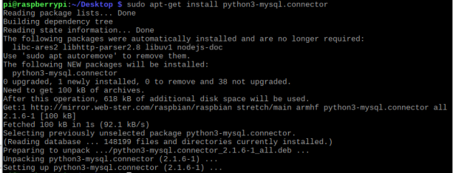

**Step 6**. Along with this material, there is a python script called ‘week3_partB.py’. In the Menu, select Thonny Python IDE.

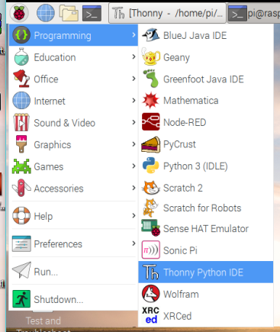

**Step 7.** Press the greenplus button to create a new python script. Copy and paste the code from ‘week3_partB.py’ to the empty script, then save the script on desktop. Click on the ‘Run’ button. 

**Step 8.** You can now go ahead and run the script. It should be giving an output in the shell like below. (Sometimes, the output will be ‘Errors’. When this happens, just reboot the Raspberry Pi and the sensors should be working again). You can also go back to the MariaDB and the data should be already inputted into the table.

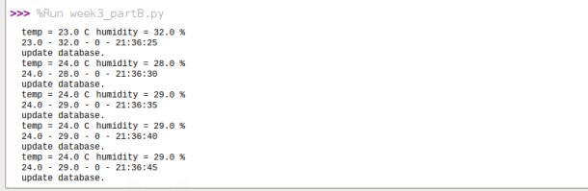

**Step 9.** Study the code and try to understand the logic behind it. It’s fully commented.

Reference:

1. <https://www.youtube.com/watch?v=iycNe-ZThOM>
2. <https://www.youtube.com/watch?v=yPu6qV5byu4&t=811s>
3. <https://askubuntu.com/questions/1014947/mysql-connector-python-importerror-no-module-named-mysql>
4. <https://gist.github.com/dschep/24aa61672a2092246eaca2824400d37f>
5. <https://mariadb.com/resources/blog/how-to-connect-python-programs-to-mariadb/>